Introduction
The goal of this specification is to describe a format being able to handle HRTF data. The format is intended to be easily extendable, highly portable, and actually the greatest common divider of all publicly available HRTF databases at the moment of writing. The format should not only be able to describe simple HRTF measurements, but also to include measurements of something fancy like BRIRs with a 64-channel mic-array in a multi-source excitation situation or directivity measurement of a loudspeaker.
In the process of developing the HRTF format, we need to consider the following steps:
- find the appropriate structure for our data and meta data
- decide which data and meta data do we want to store within the structure (assure simplicity of future expansion)
- find a numerical container which will be able to store the structure.

Description of the Measurement Setup
The following parts of the measurement setup should be considered:
- Room: The volume enclosing the measurement setup. This is where the measurement happens and could also be free-field.
- Receiver (R): any acoustic sensor like the ear or a microphone
- Listener (L): the object incorporating all the Receivers. For humans it could be the head, for mic-arrays it could be the sphere or the frame. The head is important because when we attempt to describe measurements done for multiple positions in a room, the position of the head would vary.
- Source (S): any acoustic source like loudspeaker, human, animal, technical device, or musical instrument
- Transmitter (T): Particular driver of the loudspeaker or a particular loudspeaker in a speaker array, or a particular human in a choir or...
- Object(s): Optional additional parameters of a measurement. For example, in the measurements done at TU-Berlin, the angle between the torso and the head is varied as an independent variable.
Below, there is a schematic overview of a general measurement setup. In this case, the room is defined by two opposite corners relative to the origin. The source consists of multiple loudspeakers (T1...n); the listener is a microphone array consisting of several microphones (receivers R1...n).

Requirements
- APIs: as transparent as possible for Matlab, Octave, C++
- Ad-hoc capability of storing the following HRTF databases:
  - CIPIC
  - LISTEN
  - T-Labs
  - MARL-NYU
  - Nagoya
  - ARI Database
- Compression on board
- Description of the measurement scene in free-field and reverberant spaces
- No limitation to two microphones. No limitation to one source.
- Hierarchical description when coming free-field HRTFs (simple setup) and going to more complex setups like mic-array measurements in reverberant spaces, excited by a loudspeaker array (complex setup).
- Global geometry description (related to the room), and local geometry description (related to the listener/source)
- Geometry description: Compatibility with as many software packages as possible (Blender, GoogleEarth,...?)

Structure
In order to describe the measurement situation, we split all the information in two parts:
- data: the numeric description of the measured systems (e.g., impulse responses, complex spectra, etc.), and
- meta data: data's semantic description (e.g. geometric measurement setup, orientation of the head, sampling rate, etc). Within the meta data, no further structure is allowed in order to keep the format as simple as possible.

Data and Meta data
The discussion process about the structure compares the previous available formats and basing on their needs we provide suggestions which fits all of them. In the discussion process, we consider the following formats/software packages: ARI, T-Labs, MARL-NYU, SDIF, and openDAFF.

Data
Data stores the signal-based description of the measurements. In the most simple case, it is a matrix containing impulse responses for each measurement and receiver channel. However, we want to include more sophisticated data types and thus we use the attribute DataType to determine the type of the data. Note that DataType, being a meta data itself, is stored in the metadata – not data – structure.
In the table below, we compare the different data types used at the various labs until now. In the table, “How to store” shows our suggestion on how to store the data for the corresponding data type. Each field in “How to store” represents a 3-D matrix. (TODO: maybe 2D + struct)
- Sample: the extension of the system description along the main dimension. For impulse responses, “Sample” corresponds to the number of time samples. For Spectrum, “Sample” corresponds to the number of frequency bins.
- Measurement (M): the index of the measurement available in the file.
- Receiver (R): the index of receiver channels used in the measurement. For HRTFs, we have 2 receivers corresponding to the left and right ear. For mic-array measurement, one receiver corresponeds to one mic of the array.
For example, for the FIR DataType, Data is [sample x measurement x receiver]. (TODO: maybe 2D + struct)
ARI | T-Labs | MARL-NYU | SDIF | openDAFF | How to store | DataType
hM | left,  right | data.IR | XFIR | yes | Data | FIR
 |  |  |  | yes | Data | Spectrum
 |  |  |  | yes | Data.Mag,  Data.Phase | SpectralMagnitudePhase
 |  | data.IR | XFIR,  XITD |  | Data | FIRITD
hM |  |  | XIIR |  | ???  Data | IIRBiquad  FIRTOA
??? |  |  |  |  | ??? | Subband

Metadata
[Metadata] is a structure with attributes describing the measurement:
- The comparison and description of the attributes used by the various labs can be found in the accompanying spreadsheet file.
- In order to keep it simple, we do not allow structures within Metadata. But we can group some common attributes by using prefixes in the attribute names, e.g., Measurement.
- All attributes must have one of the following dimensions:
  - general string and numeric variables: [1 1], [1 x], [M 1], [M x]
i.e. a scalar value [1 1] means that this value is valid for all measurements (typical example: sampling rate)
i.e. an [M 1] matrix means that there are different values for each measurement (typical example: measurement ID)
i.e. an [M x] matrix means that there are different values for each measurement and (for example) for each receiver
  - The data variable (where the actual measurements are stored) defines the dimensions M (number of measuremnts) and R (number of receivers). The dimension of data is [M R] with sub-structs of length N (number of samples) to store the data (FIR, spectrum, etc.).
  - Meatdata for the description of the geometry (coordinates, vectors, angles): [1 3] or [M 3]
Again, it is possible to either use one triple of values for all measurements or use different triples of values for each measurement (i.e. does the position change during the measurement?).
  - Note that in Matlab, cells should be used for array of strings
- If an attribute is not provided but mandatory, a default value is used (TODO: implement this in API). If the scheme does not provide a default value for a mandatory attribute, the read/write functionality should result in an error.
- We could discuss how to encode the vectors in order to provide a better computational efficiency ([3 x measurements] versus [measurements x 3]). For clarity reasons, I suggest to encode the dimension “measurement” in the rows always.
Click to see a complete list of [Metadata].

Description of the geometry
Issues:
- Global coordinate systems for the room, source, and the listener. The coordinate type must be one of the proposed types for the positions and orientations. The coordinate types can be different for the room, source, and/or listener. The reference for the position is the reference given by the room description.
- Local coordinate systems for the transmitters and receivers, relative to the source and listener coordinate systems, respectively. The coordinate type must be one of the proposed types and may differ from the types chosen for the global coordinate types.
- Geometry of the room:
  - Important: do not invent anything new, use some existing format and link our file (or even embed?) with that. Candidates: POV, VirChor (deprecated!), DAE (Blender, Google SketchUp, OpenSceneGraph, Meshlab, and many others within the COLLADA, also compatible to CATT and ODEON);
  - Current suggestion:
    - no room / free-field
    - shoebox, defined by the positions of the two opposite corners of a box.
    - COLLADA: arbitrary description of a virtual scene given by a link to a DAE file. Supported by many applications.
- Source: for the loudspeaker we could consider linking to (or even embedding?) an existing format like the Common Loudspeaker Format (CLF). At least export/import function would be nice because they provide a viewer...
Position and orientation of source/listener and transmitters/receivers (subject to constant change...):
- Source/ListenerPosition is a point in an absolute coordinate system (different coordinate types may be used)
- The orientation of the source/listener is given by a view-vector which defines the direction in which the source/listener "looks"
- For uniqueness of the orientation, it is necessary to also specify an up-vector which defines where the "top" of the source/listener is. We suggest that up-vector and view-vector have to be orthogonal. If this is not the case the up-vector will be projected into a plane which is orthogonal to the view-vector (this is open for discussion, though).
- Additionally, the source/listener's rotation can be changed further by azimuth, elevation and twist offset angles. In certain cases, varying the rotation will be quicker and more intuitive than varying the view-vector (i.e. HRTF measurement, see example below)
- The default orientation for the source/listener is: view-vector on x-axis, up-vector on z-axis. It is yet to be discussed whether this default orientation is fixed or can be changed by the user.
It will be important to agree on an exact definition of these rotaions. Firstly, the order of the three rotations is important. Secondly, it has to be decided whether the rotation axes of the second and third rotation remain in the original coordinate system or will also be affected by the rotations. Currently, we aim for the second option.
- Transmitter/receiver positions are relative to the source/listener position. When the source/listener position is at the origin and the orientation is default, the local source/listener coordinate system and the global coordinate system are identical (except for different coordinate types).
The figure below shows a listener in a room, given by two opposite corners of the room. The position of the listener is given in global coordinates (i.e. "relative" to the origin), whereas the positions of the receivers are relative to ListenerPosition. If the listener is rotated or shifted to a different position, the receivers will also move, accordingly.

It is yet to be discussed, what happens to the view- and the up-vector when the position of the listener changes. Basically, both vectors are unaffected by this translation, so the orientation remains the same. However, in some cases it might be convenient to specify that the listener "always looks at the source", regardless of the listener's position. For example, there could be an agreement, that this kind of orientation is assumed when (0,0,0) is given for view- and up-vector. Another possibility is that this kind of orientation is assumed when no view- and up-vectors are given.
Examples of measurement setups which should be considered:
- Free-field HRTF measurement
  - Listener: the head, position constant, ListenerView-vector on x-Axis, variation of azimuth, elevation and twist offset by ListenerRotation
  - Receivers: 2 ears = 2 receivers, position is given relative to ListenerPosition, receivers are affected by ListenerView-vector and ListenerRotation. I.e. varying one of the angles of ListenerRotation changes the rotation of the entire source. Therefore, the absolute position of the receivers changes as well (illustrated in green in the graphics below).
  - Source: the loudspeaker, fixed position on y-axis at a constant distance from the listener, SourceView-vector towards listener
  - Transmitter: no information (default one transmitter at ListenerPosition)
  - Room: no information (free-field)
  - Please refer to the 'ARI to SOFA' script in the "Code" section to see this setupc in a practical example using the SOFA format.
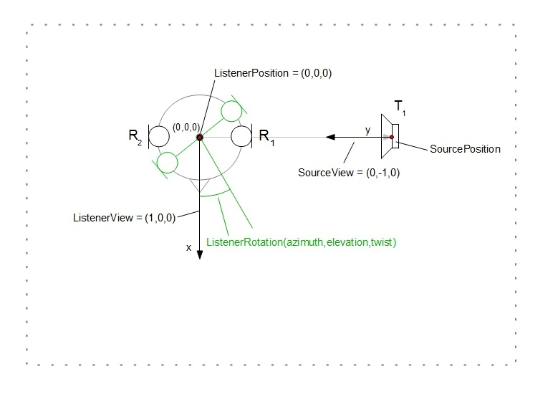
- BRIR measurement at various listener positions
  - Room: somehow described (simple: shoebox (like in the figure); complex: triangular mesh)
  - Listener: the head, position varies, ListenerView-vector reamains constant, variation of azimuth, elevation and twist offset by ListenerRotation
  - Receivers: 2 ears
  - Source: the loudspeaker, fixed position somewhere in the room, SourceView-vector constant
  - Transmitter: no information (default one transmitter at ListenerPosition)
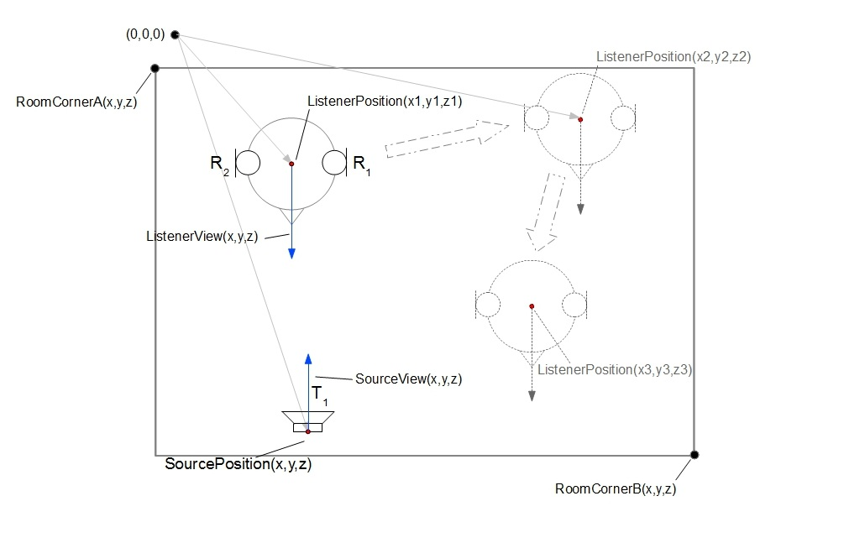
- Mic-array measurement in a room, having a line-array of speakers as excitation; each data item describes the IR of one speaker
  - Listener: the array, positioned in the room, ListenerView-Vector looks at the center of the speaker array
  - Receivers: 64 mics, receiver #1 is on axis of ListenerView-Vector, the rest described in spherical coordinate system
  - Source: speaker array, positioned somewhere in the room, SourceView-vector looks at the listener
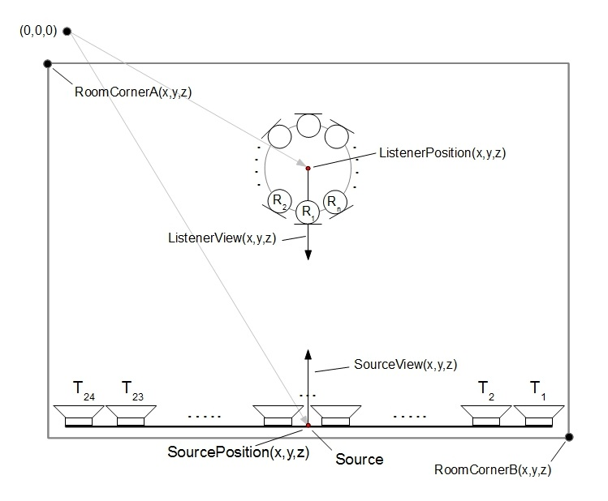
  - Transmitter: 24 speakers; #1 is right, #24 is left, center is between #12 and #13.

- BRIR measurement with variable torso (TU-Berlin setup), excitation with a saxophone, playing at different orientations
  - Room: some description;
  - Listener: the head, position varies, ListenerView-vector reamains constant, variation of azimuth, elevation and twist offset by ListenerRotation
  - Receivers: 2 ears; no further information;
  - Obejct: the torso orientation (in global coordinate system!) may vary;
  - Source: the instrument; position fixed, SourceView-vector varies;
  - Transmitter: no further information.

- RIR as a function of the room temperature
  - Room: no further information;
  - Listener: the mic, fixed position and ListenerView-vector;
  - Receiver: no further information;
  - Source: the loudspeaker, fixed position and SourceView-vector;
  - Transmitter: no further information;
  - Object: temperature, varies.

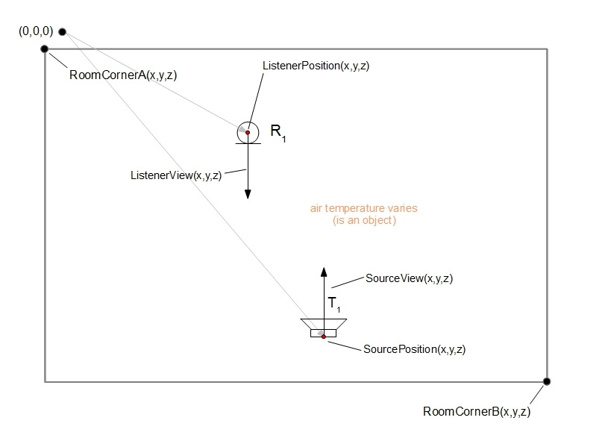

- Directivity pattern of a two-way loudspeaker (in free-field)
  - Room: no further information;
  - Listener: the mic, fixed position and ListenerView-vector;
  - Receiver: no further information;
  - Source: the loudspeaker, fixed position, variation of azimuth, elevation and twist offset by SourceRotation
  - Transmitters: 2 (woofer, tweeter); position of the woofer: origin; position of the tweeter: 10 cm higher.

Coordinate types
The information about the position and orientation are stored in custom formats. The attributes “OrientationType” and “PositionType” describe the type of the coordinate system used for the description of all positions and orientations, respectively and must be one of the following:
- Cartesian: [x y z]; all fields in meter
- Spherical: [azimuth (deg, 0…360) elevation (deg, -90…+90)]; the poles are in the median plane, front is [0;0]; top is [0;90], left is [270;0]; back is [180;0]
- Navigational: [azimuth (deg, -180...+180) elevation (deg, -90...+90)]; the poles are in the median plane, front is [0;0]; top is [0;90], left is [90;0]; back is [180;0]
- VerticalPolar: [azimuth (deg, -90...+90) elevation (deg, -90...+270)]; the poles are in the median plane, front is [0;0]; top is [0;90], left is [90;0]; back is [0;180]
- HorizontalPolar: [lateral (deg, -90...+90) elevation (deg, -90...+270)]; the poles are in the horizontal plane, front is [0;0], top is [0;90], right [-90;0]; back is [0;180]

Schemes
To fit the needs of different labs and ease the transition from their to our format, we define schemes of meta data and provide them as examples for the various labs. The schemes can be extended by everybody: all the schemes will be hosted on a wiki-page – new contributions are welcome and will be incorporated into the HRTF format with the assistance of the format developers.

Numerical container
All the information is stored in a numerical container and saved in a file. Our aim is to use an existing container format and to achieve a transparent access to as many applications as possible. We have the following favorites at the moment:
- HDF5 format:
  - data handling on different operation systems,
  - support of many data types,
  - excellent real-time capability because of (parallel if required) access to parts of the file,
  - huge-file support,
  - native and library-based read/write supports in Matlab,
  - native read support in Octave,
  - API available for C, C++, Java, and Fortran 77, and compile on Linux, MacOS, Windows (see here)
  - Compression with GZIP allowed. Writing compressed files with a commercial software is not explicitly allowed when using SZIP.
  - unclear how to use HDF5 in Octave.
- netCDF:
  - based on HDF5,
  - obligatory naming of dimensions
  - library-based read/write support in Matlab,
  - library-based read/write support in Octave,
  - API available for C, C++, Java, Fortran 77, and Fortran 90, and compile on Linux, MacOS. Problems on Windows with MS Visual Studio (see here)
  - disadvantages with respect to HDF5:
    - additional layer requiring binding to two formats: HDF5 and netCDF.
    - handling in Matlab not as transparent as with HDF5
    - dimensions must be named; in worst case, this causes separate dimension names for each matrix in the file
  - advantages with respect to HDF5:
    - write support for Octave
- CDF:
  - similar to HDF5 and netCDF, see the comparison
  - allows a multi-file representation
  - library-based read/write support in Matlab,
  - API available for C, C#, Pearl, Java, Fortran, and compile on Linux, MacOS, and Windows with MS Visual Studio (see here)
  - License: completely free even if using compression in commercial products, see here
  - Problem: there seems to be no support for octave (???)
- SDIF
  - Looks like a small brother of HDF5:
    - No compression
    - Mixed ASCII/Binary representation
    - Not very spread around various scientific organizations
  - Octave support not clear (???)
  - Advantage: IRCAM would have no need to convert/adapt

Ideas / To Do:
Next Steps:
- Clarify how HDF5 can be used in Octave After a discussion on the octave mailing list, it seems to be really hard to use the built-in HDF5 library for purposes other than the load/save commands. Hence, HDF5 is not a good option, for now.
- Work out the description of the geometry: provide some pictures
- Setup a SF project
- Implement reference APIs for arbitrary structures
- Set up the appropriate structure
Support of existing databases
The flexibility of the format is an important issue. Hence, the public HRTF databases should be checked to fit the HRTF format. All these database should be convertable to the HRTF format (the conversion functions should be provided). Note that not every data saved in the HRTF format must be convertable to one of those formats without errors.
For the AMT, an HRTF repository will be created. Within the AMT, HRTFs will be provided by downloading the required data. Once downloaded, the HRTF data will be kept in a cache.
Support of existing applications (if HDF5)
- SoundScape Renderer:
- ExpSuite: adapt the parser and some applications based on ExpSuite
- openDAFF: the HDF5 library could be included in the sources and the parser could be adapted
- Spat
- Slab3d
API (if HDF5)
The API will provide read and write functions for MATLAB and Octave. The API is kept simple: When writing to the file, the API will check for the mandatory fields and the format of the already defined data types. When reading from the file, the API will simply read from the file. The API can not support all the heterogeneous needs from the various labs, hence, no algorithms will be provided. Also, we will neither provide a viewer nor an editor: In order to view the data in terms of the numerical structure, HDF5Viewer can be used instead. In order to edit the data, MATLAB or Octave can be used – it would be hard to excel such editors. MATLAB and Octave can also be used for a graphic representation of the HRTF format by using scripts specifically customized to the own needs. For already existing specialized viewers and editors, relying on other formats, conversion functions will be provided if required.

